**INFO.EVENET MANAGEMNT…**

Sponsored by

# @_SAI_EVENTS _&_FLAMES_

*Under the guidance of* **Pranjal Pandhare**



Submitted to

**Department of Commerce**

**Sinhgad College of Science**

**Pune -41**



# Savitribai Phule Pune University

Partial fulfillment of

SYBBA-CA

Submitted by

**Student Name**. *Pranav Sunil Patil*

**Seat No. 2127**

**Student Name**. *Dipak Amar Patil*

**Seat No.2125**

# *Certificate*

This is certify that the project entitled “INFO.EVENT MANAGEMNT…” which is being submitted herewith for the partial fulfillment of award of the **SY BBA-CA**  of Savitribai Phule Pune University. This is the result of the original work completed by **Patil Pranav & Patil Dipak** under my supervision and guidance and to the best of my knowledge and belief the work embodied in this project has not formed the earlier the basis for the award of any Degree or Diploma or other similar title of this or any other University or examining body.

*Date :*

*Place :*

Guide Internal External

Dept of Commerce Examiner Examiner

## Declaration

I hereby declare that the project entitled Patil Pranav & Patil Dipak completed and written by me has not previously formed the basis for the award of any degree or diploma or other similar title of this or any other university or examining body.

Date :

Place :

STUDENT SIGNATURE

### Acknowledgement

With deep sense of gratitude and indebtedness, I thank my research guide

Prof. Pranjal Pandhare Head, Department of Commerce (**BBA-CA) SY** and **Dr** **Magan Ghatole** Principal, Sinhgad College of Science , Pune for his /her constant encouragement, inspiring guidance, constructive criticism and valuable suggestions during entire research work. Working with him has been a great joy, which was not at all spoiled by customary formalities and unnecessary fuss about rules and regulations.

STUDENT SIGNATURE

|  |  |  |
| --- | --- | --- |
| **Sr.** | **Contents** | **Page no** |
| 1. | Company Profile (optional) |  |
| 2. | Introduction to the project | **7** |
| 3. | Scope of Work | **8** |
| 4. | Feasibility Study | **9** |
| 5. | Need for System | **10** |
| 6. | Operating Environment - Hardware and Software | **11** |
| 7. | Proposed System  7.1 Objectives to be fulfilled  7.2 User Requirements  7.3 System Features  D.F.D.'s and ER's | **12**  **13**  **14**  **15,16** |
| 8. | User Interfaces | **17** |
| 9. | Design of Output screens and reports | **18-21** |
| 10. | Drawbacks and Limitations | **22** |
| 11. | Future Enhancement | **23** |
| 12. | Conclusions | **24** |
| 13. | Bibliography | **25** |

N.B.: Above titles of chapter and points are for reference only. Use appropriate words / headings in your report.

### 

### Abstract

Abstract may have more than one paragraph giving an overview of what problem has been taken with an cover introduction to the broader area of spectrum, importance, proposed approach and results/ performance obtained. Use 1.5 line spacing. Use font Times New Roman size 12 and 1.5 line spacing throughout the text of the report.

All titles should start on the first line of the page without giving any space.

Margin layout should be Top, bottom, left and right: 1” margin. No indents for the paragraphs written throughout the report. Always justify the contents.

Page numbers starting from ‘1’ with middle of the page setting has to be given from abstract onwards. No numbering should be given for certificate. Number size is 12, times new roman.

#### 

#### Introduction

The project aims to develop a comprehensive website for "Sai Events

& Flames" a premier destination for event planning and design needs. With a commitment to creating extraordinary celebrations, the website will showcase a wide range of services to turn special moments into unforgettable memories. Whether you're planning a corporate conference, a grand wedding, or a community gathering, we've got you covered. Our user-friendly interface, robust features, and dedicated support make organizing and hosting events a breeze. Join us and take your events to the next level!"

#### 

#### Scope of Work

#### 

1. ***Website Structure***: Creating basic and formal structure of event management web site.

1. ***Product Display***: Present service items with it’s name and more information option...  also every service item have a dedicated page’s witch includes it’s **NAME , IMAGE , DESCRIPTION & PRICE DETAIL’S** as par its setup’s .

1. ***User Accounts***: Enable account creation and secure login for personalized experiences.
2. ***Responsive Design***: Ensure compatibility and usability across various devices and browsers

#### 

#### Feasibility Study

***Technical Feasibility***: Assess skills and resources for frontend development. Evaluate suitability of HTML5, CSS3 & JSES6 for project. Ensure accessibility of development tools.

***Economic Feasibility:*** Estimate budget for required resources. Analyze potential return on investment.

***Operational Feasibility:*** Assess project management feasibility. Ensure availability of technical support like feedback form. Consider user acceptance factors.

***Schedule Feasibility***: Develop project timeline. Allocate resources effectively anddecision with customers about management.

***Legal and Ethical Feasibility***: Ensure compliance with copyright laws. Address data privacy concerns.

#### 

#### Need of the System

***Learning Tool***: Helps students practice web development skills practically, improving their understanding of HTML and CSS.

***Skill Building:*** Develops frontend development abilities, including layout design and responsive web design techniques.

***Portfolio Booster***: Enables students to showcase their web development projects, enhancing their resumes for future opportunities.

***E-commerce Insight:*** Offers firsthand experience in building ecommerce features like product listings and search functionality.

***Theory to Practice:*** Bridges theoretical concepts with practical application, reinforcing learning and problem-solving skills.

|  |  |
| --- | --- |
| **System Requirements :** |  |
| **Hardware Requirement:** | MICROPROCESSOR :Pentium III and above  RAM :512 MB or more  HDD :512 MB |
| **Software Requirement:** | FRONTEND : Microsoft Visual Basic 6.0  BACKEND : Microsoft Access  2007OPERATING SYSTEM : WINDOWS  2007,WINDOWS 95 |

### 

### Proposed System

***7.1 Objectives of the Study***

***Learn Web Development Basics***: Acquire foundational knowledge and practical skills in web development by creating info. Event Management website using HTML ,CSS & J.S .

***Understand User Interface Design***: Explore principles of user interface (UI) design by creating business key features of Event Management site , such as navigation menus, service listings , color combination , multiple dedicate sections, responsive web designing .

***Practice Responsive Web Design***: Gain experience in designing websites that adapt seamlessly to different screen sizes and devices, ensuring a consistent user experience across desktops, tablets, and smartphones.

***Develop Event Management Understanding***: Gain insights into the functionality and features of e-commerce platforms by implementing basic events elements like services listings , more about us services details pages.

***Enhance Problem-solving Skills***: Coding can help students to develop problem-solving skill by abilities crucial for web

projects

***7.2 User Requirements***

***User Registration and Login***: Provide a seamless and secure process for users to create accounts and log in to the website.

***Browsing and Searching:*** Enable users to easily navigate through product categories and find specific items using a search feature.

***Product Listings:*** Present clear and detailed information about products, including images, descriptions, and prices, to facilitate informed purchasing decisions.

***Shopping Cart and Checkout Process:*** Allow users to add items to their shopping cart, review their selections, and complete the purchase securely through an intuitive checkout process.

***Account Management:*** Offer users the ability to manage their account details, including personal information, addresses, and payment methods, to streamline future transactions.

***Responsive Design and Accessibility:*** Ensure that the website is accessible and userfriendly across various devices and complies with accessibility standards to accommodate users with diverse needs.

***7.3 System Features***

***Homepage:*** The homepage will feature the slogan **"We Create Your Celebration Greater Than Better"** prominently, along with the disruptive statement emphasizing Sai Events & Flames as the premier destination for event planning and design needs. It will provide a brief overview of the services offered

***User-Friendly Navigation:*** The website will have intuitive navigation with clear menu options, making it easy for visitors to explore different sections and find relevant information.

***Brand Consistency***: The design elements, including the logo, color scheme, and typography, will align with Sai Events & Flames' brand identity, reinforcing brand recognition and credibility

***User friendly UI:***

***User friendly UX:***

***Responsive web design:***

### 0.0 level DFD

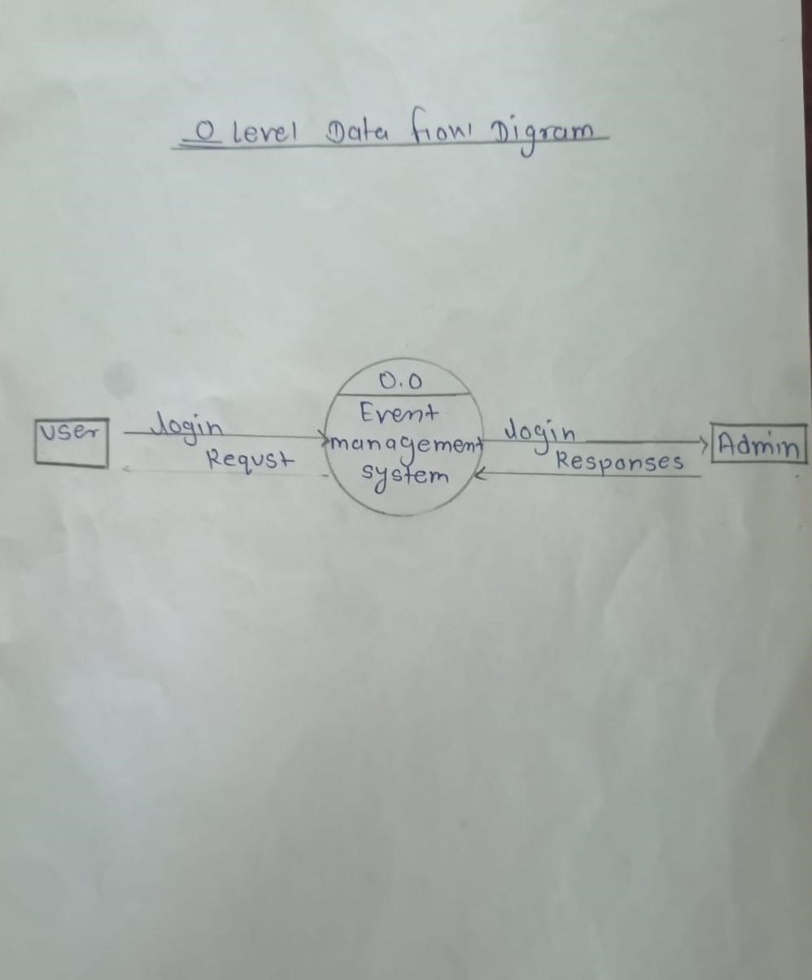

### 1.0 level DFD

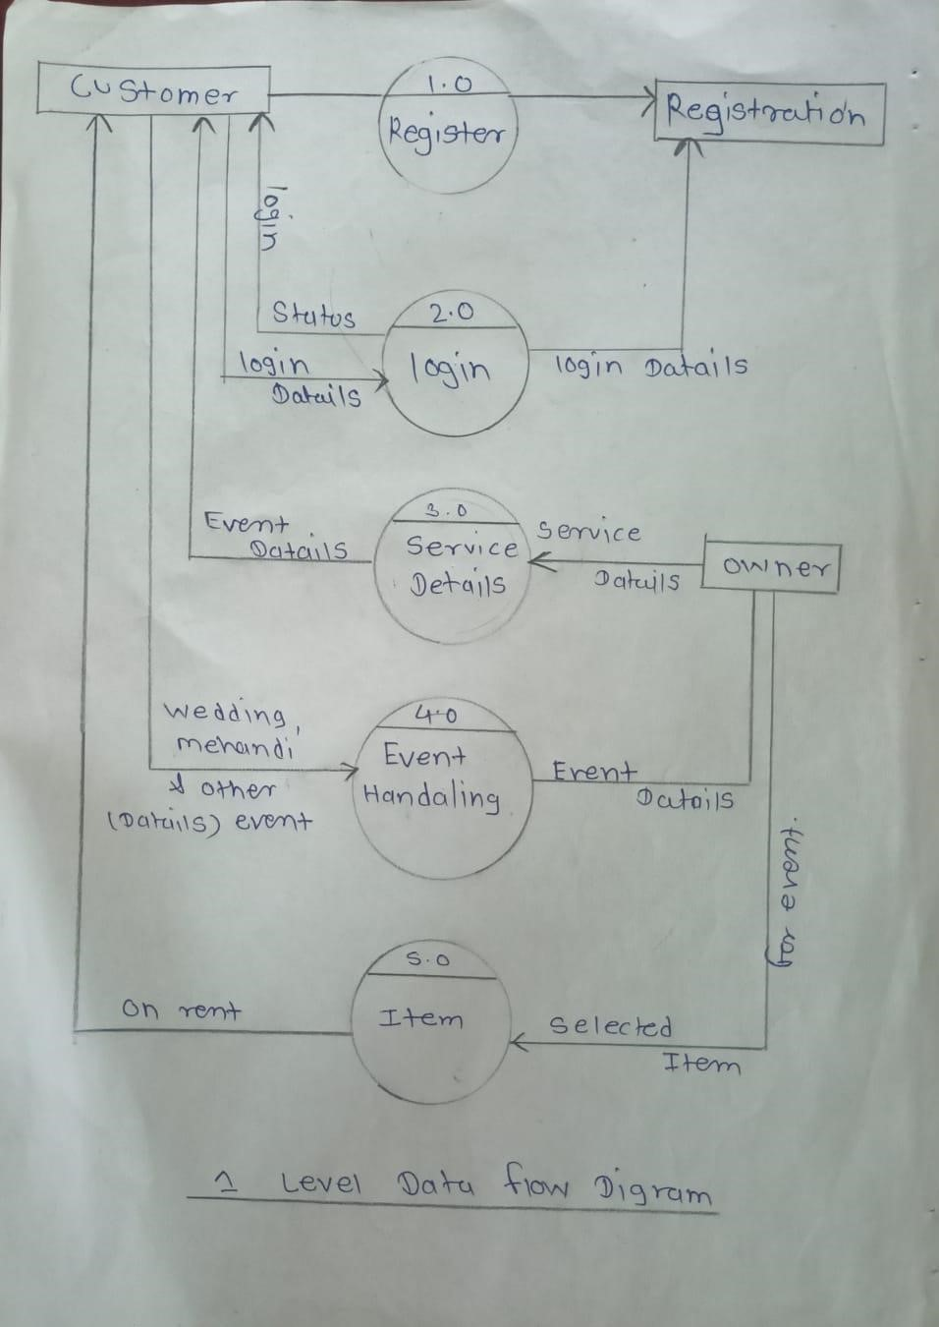

### HOME PAGE

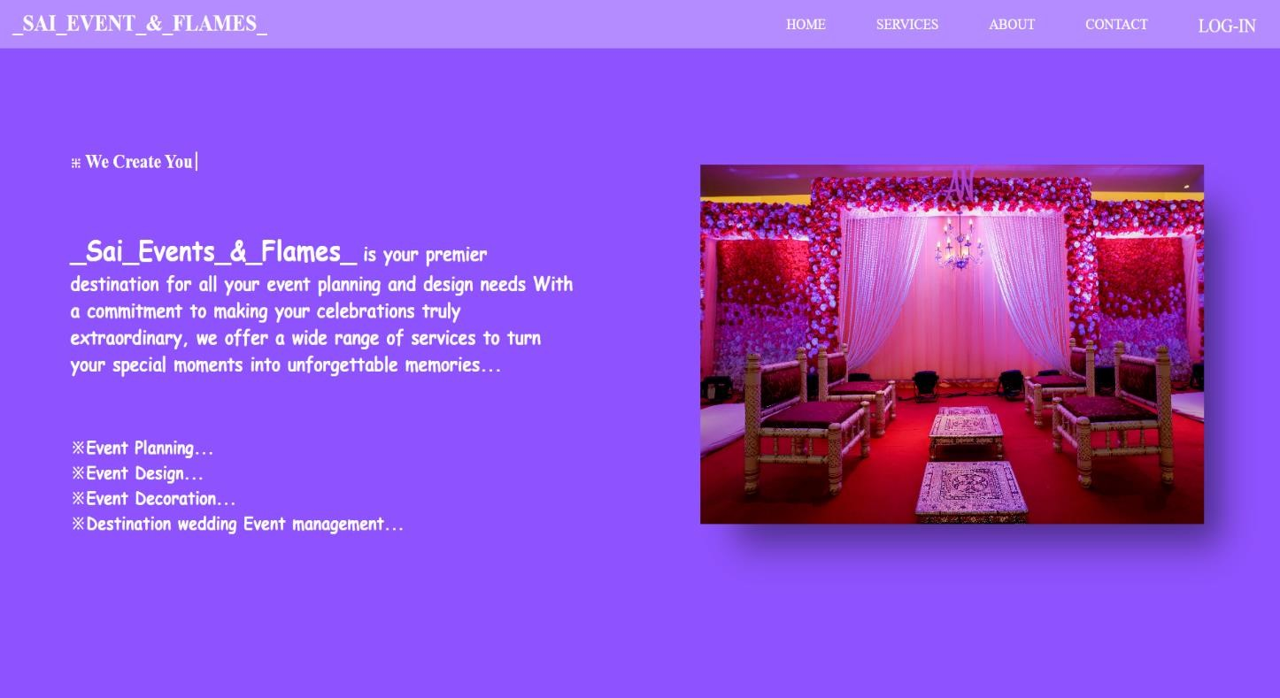

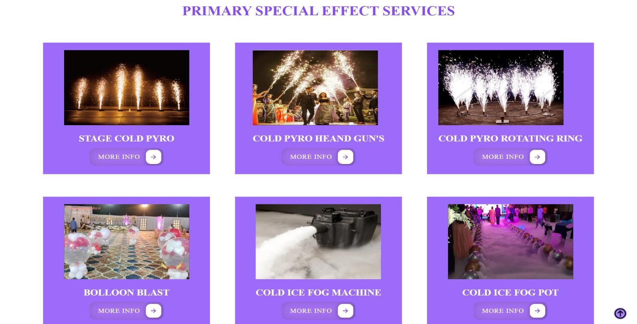

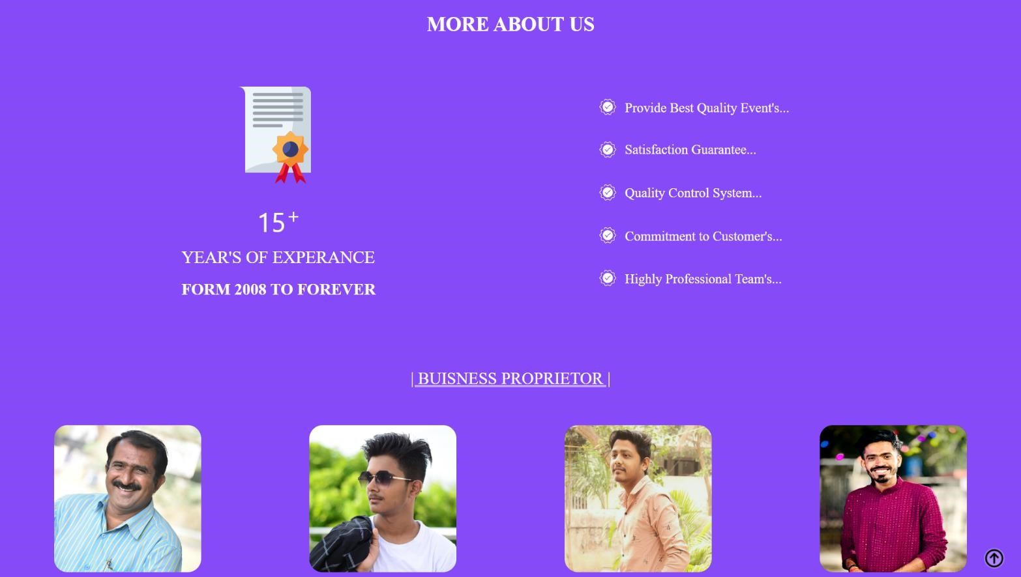

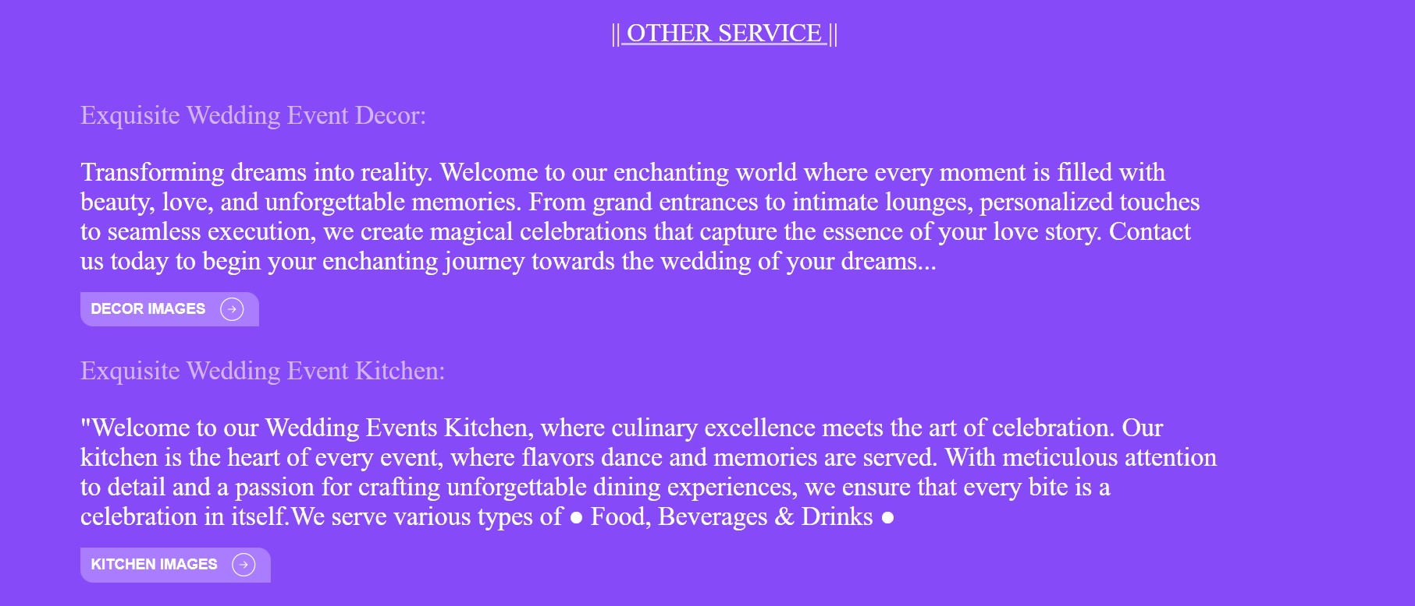

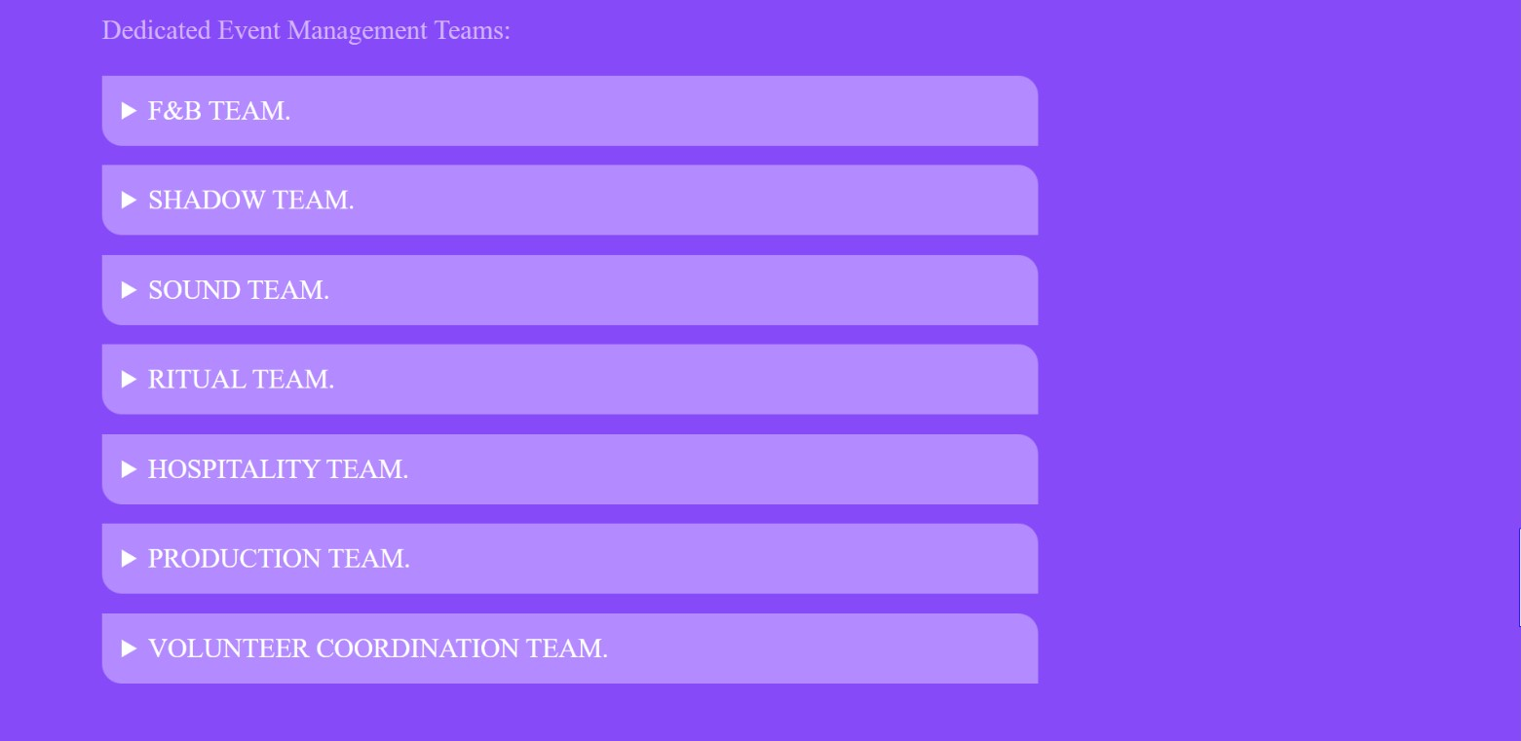

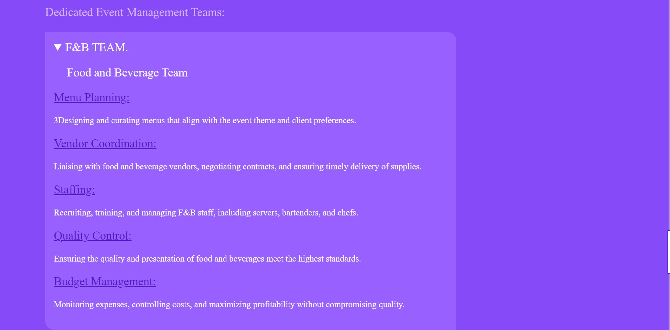

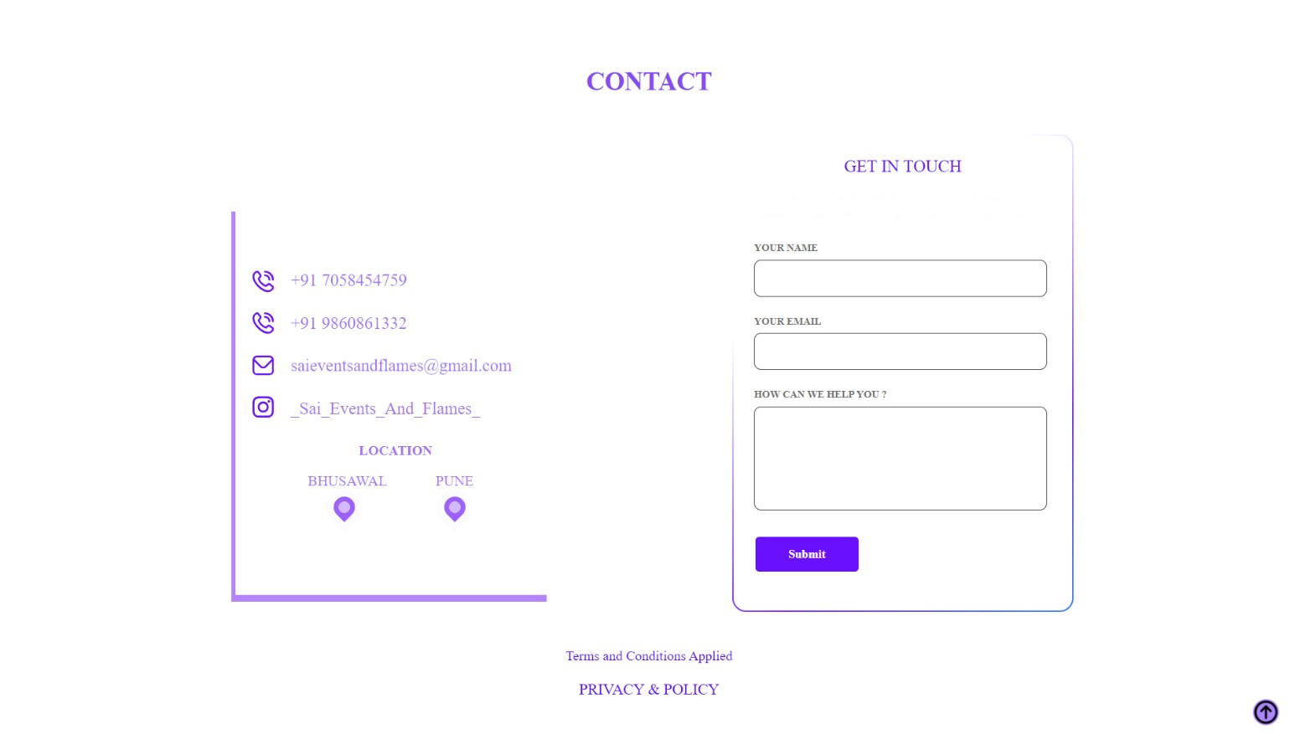

#### LOG-IN & REGISTER PAGE

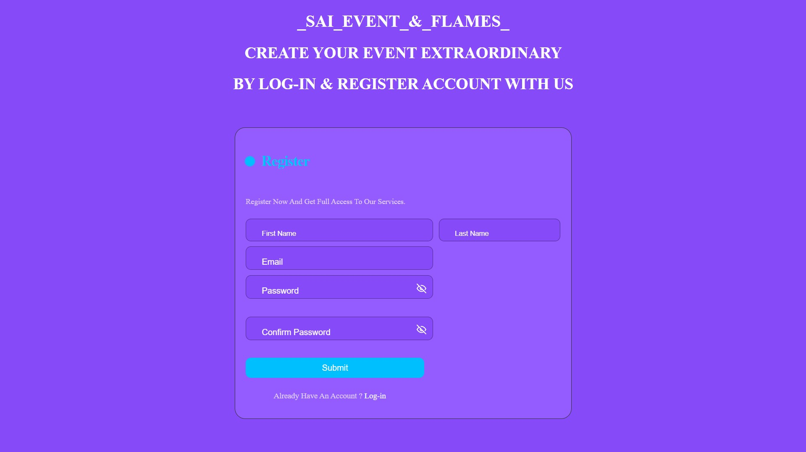

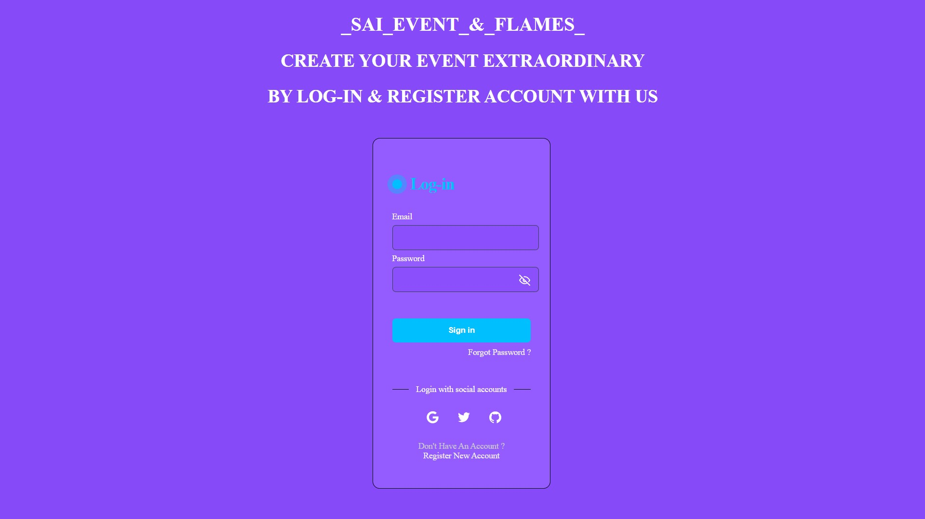

#### 

#### Drawbacks and Limitations

***Limited Functionality***: Basic websites may lack advanced features such as real-time updates, personalized user experiences, or interactive event planning tools. This can limit the overall functionality and user engagement.

***Scalability Issues***: As the number of events and users grows, a basic website may struggle to handle increased traffic and data volume. Scalability issues can lead to slow performance, downtime, or system crashes.

***Security Concerns:*** Basic websites may not prioritize robust security measures, leaving them vulnerable to cyberattacks, data breaches, and unauthorized access. This can compromise sensitive information related to events, attendees, and payments.

***Lack of Customization:*** Users may find limited options for customization in terms of design, features, and event management tools. This can restrict their ability to tailor the website to specific event requirements or branding preferences.

***Integration Challenges***: Integrating the website with external platforms, payment gateways, communication tools, or social media channels may pose challenges due to limited compatibility or technical constraints.

### 

### Future Enhancement

***Responsive Design:*** Ensure the website is fully responsive across devices, including smartphones and tablets, to provide a seamless user experience and accessibility for all users.

***Advanced Event Management Tools:*** Integrate features such as event registration, ticketing, attendee management, and schedule planning to streamline the event organization process.

***Personalization Options***: Implement personalized user profiles, preferences, and notifications to enhance user engagement and provide tailored experiences based on individual interests.

***Social Media Integration:*** Enable seamless integration with social media platforms for event promotion, sharing, and engagement, leveraging social media APIs and tools.

***Real-time Updates:*** Implement real-time updates and notifications for event changes, announcements, or important information to keep attendees informed and engaged.

## 

## Conclusion

The Sai Events & Flames website will serve as a dynamic platform to showcase its expertise in event planning and design, attracting potential clients and fostering engagement with existing ones. Through its user-friendly interface, captivating visuals, and informative content, the website will effectively communicate Sai Events & Flames' commitment to creating unforgettable celebrations.

\

### Bibliography

Note:

References should be in alphabetical order, if same authors are there, then chronological order